**Continuous Deployment Demo instruction**

# Domain name setup:

* <http://www.eqslearning.com/> : The Prod application which runs the previous version of the application.
* <http://green.eqslearning.com/> : The A side of the application which will have previous version or production version. It is possible that Internal DNS load balancer will be pointing the production URL to blue version of the application. i.e: <http://www.eqslearning.com/> is internally routed to <http://green.eqslearning.com/> and all user traffic is processed in here.
* <http://blue.eqslearning.com/> : The B side of the application, Here we will be deploying the new version of the code and perform the tests.

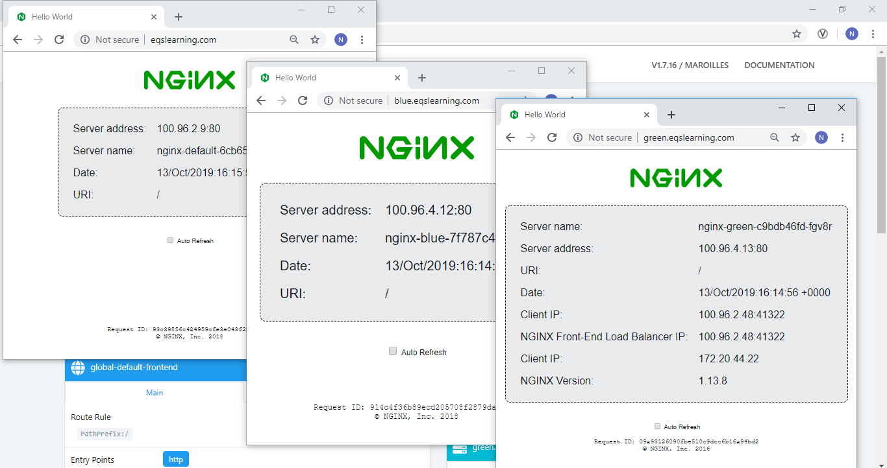

# Demo Setup

3 applications are deployed in Kubernetes Cluster. All are nginx default page displaying the underneath server Info including the pod name and IP address.

Source code for deploying the application is placed <https://github.com/k8s-fleetman/deploytypes>

There are four branches in the repository. Each branch is to update the routing mechanism.

* Master: Default routing, eqslearning.com points to ngnix-default application.
* Green deploy: Deploys all applications and points nginx-green to eqslearning.com
* Blue deploy: Deploys all applications and points nginx-blue to eqslearning.com
* Canary release: Deploys the application and points 70% traffic to nginx-green on weighted.eqslearning.com and rest to nginx-blue.
* Rollback – Helps to fix the routing back to original setup.

For convenience of demonstration, we have deployed a Traefik ingress router and dashboard which does route the traffic from external source to the application.

# Visualization of traffic routing

We can visualize the mapping on [http://traefik.eqslearning.com](http://traefik.eqslearning.com/). Hover over the ipaddress of backend services to view the name of the application which is pointing.

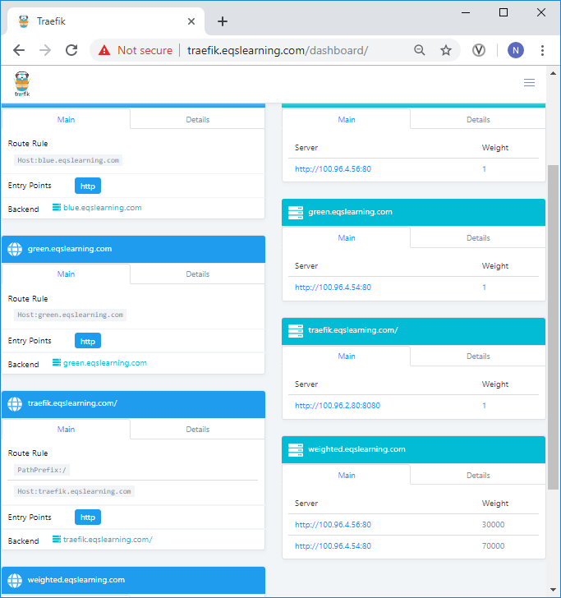

# Jenkins multi-branch pipeline for switching the traffic

Created a multi-branch pipeline in Jenkins named ‘nginx route’ which list all the branches. The deployment and ingress routing code differs in each branch. We will be running the build on each branch to give the demonstration of the Continuous deployment.

Every build will deploy the application and switch the live traffic to corresponding backend application as detailed in previous section.

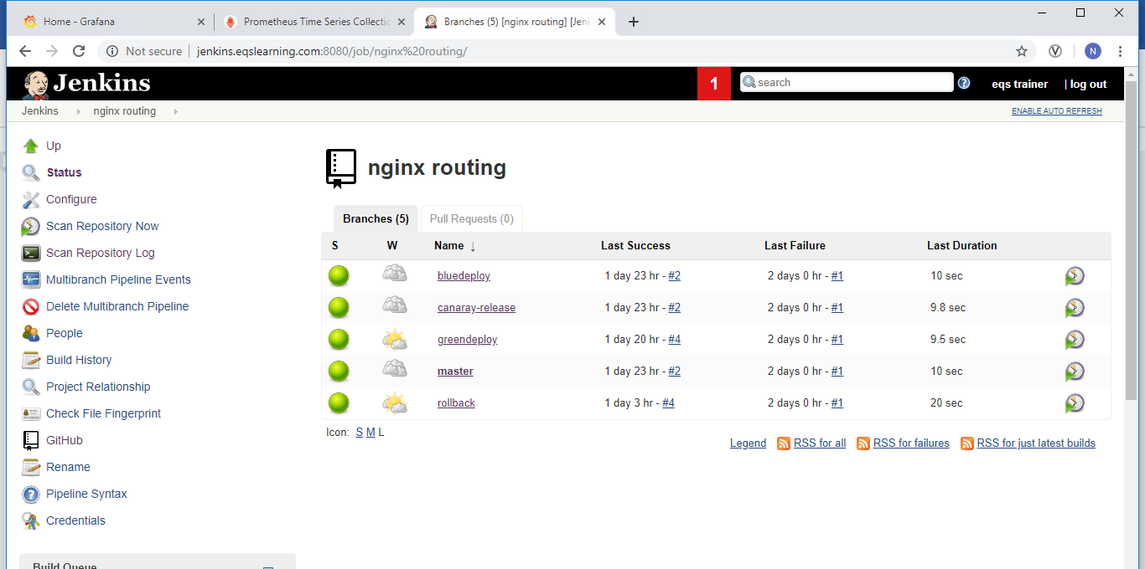

# Blue/Green deploy:

By default both green and blue applications runs all the time in the backend. By executing either **bluedeploy** or **greendeploy** branch in Jenkins multi-branch pipeline ‘nginx routing’ we will be switching the live traffic of eqslearning.com. Anytime it can be rolled back to original state running ‘rollback’ job.

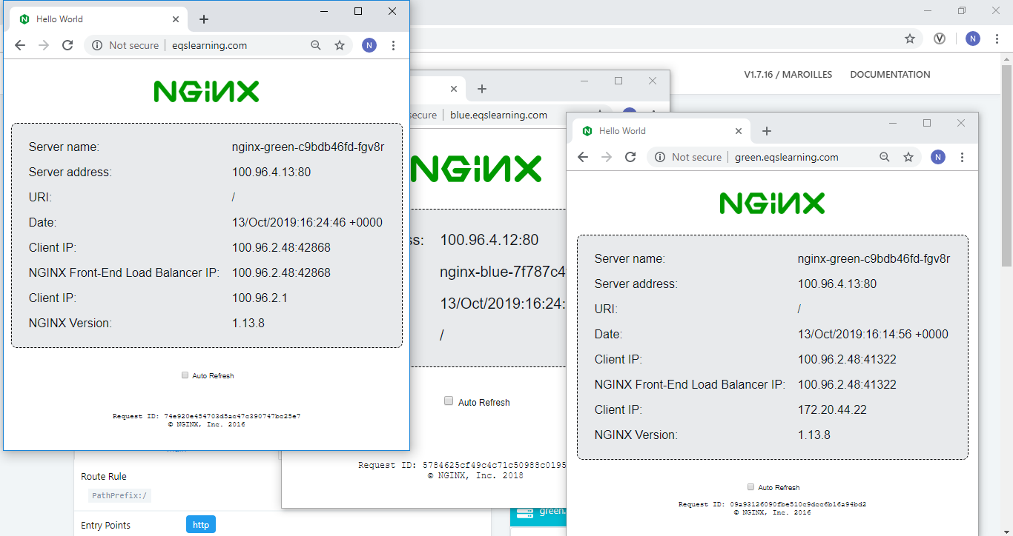

Canary Release:

Unlike blue/green setup, canary release is configured on [http://weighted.eqslearning.com](http://weighted.eqslearning.com/) where it routes the user traffic between nginx-green and nginx-blue. The percentage is defined in the canary-ingress.yaml file.

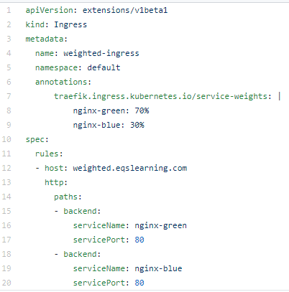

Visualizations of the canary release can be observed in two ways. Check the auto refresh option on [http://weighted.eqslearning.com](http://weighted.eqslearning.com/). The site refreshes periodically and we can observe the server name field switching between blue and green.

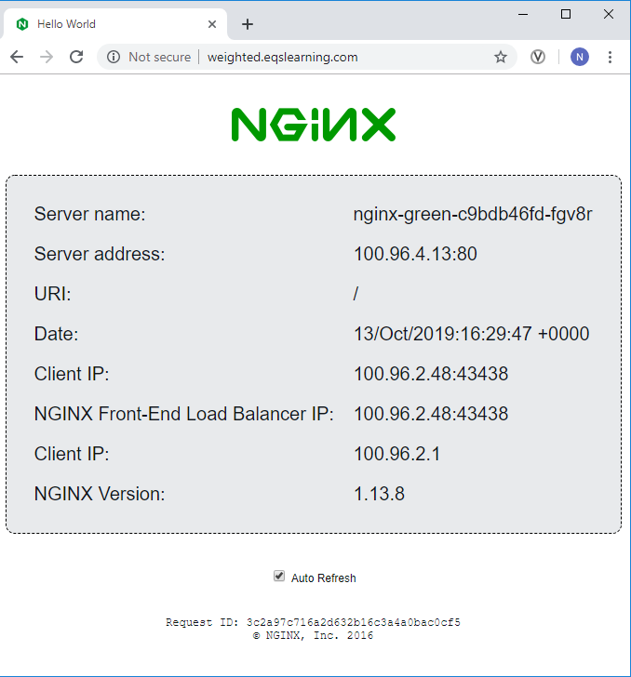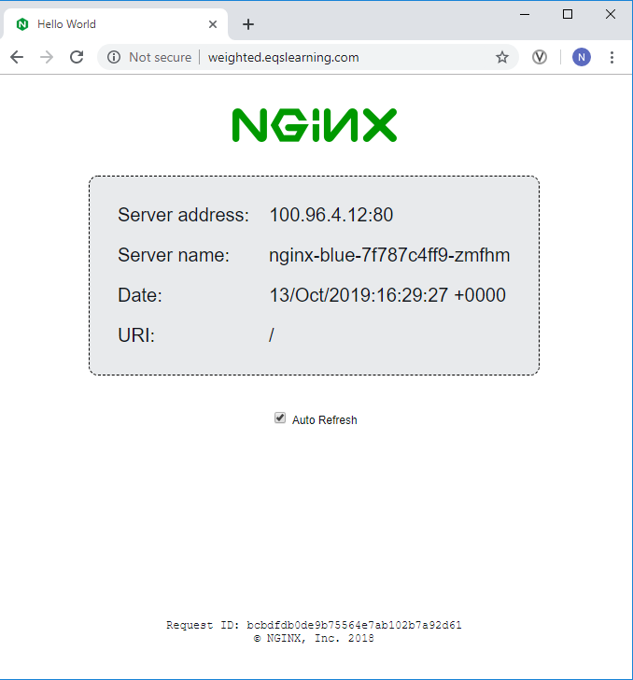

The second way is to observe the traefik dashboard where you can see the weightage is updated as 70,000 for nginx-green and 30,000 for nginx-blue.

